Born to Run
Tralee Marathon Club
Annual Report

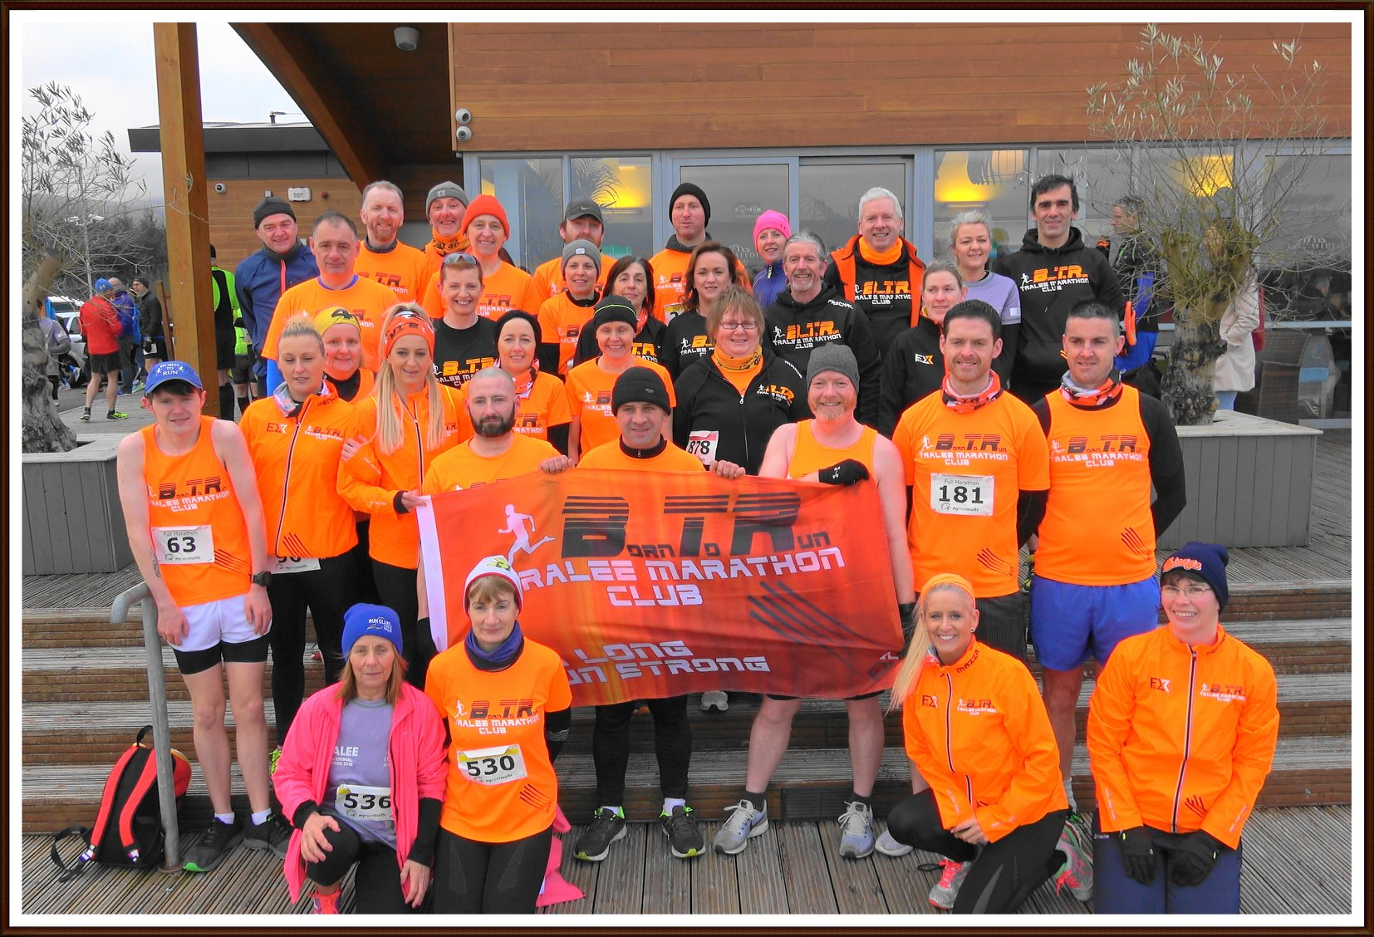

2018
Introduction
The Born to Run AGM took place at the Rose Hotel in November 2017 the following were elected to the club committee.
Chairperson: Tom Foley Vice-Chairperson: JJ O’Connell Secretary: Liam Horan
Treasurer: Martin Moore PRO: Maria Moynihan Registrar: Sandra Byrne
Fundraising Officer: Caroline McConnell Social Officer: Marilyn O’Shea
Volunteer Coordinator: Aoife O’Connor Minutes Secretary: Ann O’ Shea
Ordinary Members: , Niamh Abeyta. Ashley Kean O’Shea, Anna Stack, William Brick, Colm Griffin
The committee met approximately once a month and over the course of the year dealing with matters as diverse as, club social functions, club gear, the 40 mile ultra event, recruitment of new members, mentoring and diversification of training, fundraising, public relations communication and IT, altruism by the club, over sees trip, the Parkrun event, our ‘Dashboard Diner’, a new club event and club finances.
I would like to thank the committee members for their work and commitment over the year and all our members for representing the club with pride and distinction the length and breadth of the country and indeed the world over.
What follows is a brief description of some of the clubs achievements and activities over the year and some hopes and aspirations for the year ahead.

Social Activities
We were back at the Ashe Hotel this year for our Christmas party and again they put on a excellent welcome for us. Marilyn and her organising committee again put in a huge amount of work to ensure we had a brilliant night. The Brogue deserve a mention also as we had a couple of great nights there post Tralee Marathon and our own 40 Mile Ultra celebrations. The club also had get-togethers in Dingle, Dublin and Listowel as well as others.
Public Relations
Communicating our message to the wider public and spreading awareness of the club is vital to keeping the club vibrant and relevant. Maria has been working hard all year to this end and local media have been very supportive. Thanks to The Kerryman, Kerry’s Eye , the Tralee Advertiser , Tralee Outlook, Tralee Today and Radio Kerry for regulary covering our good news stories.
We continue to make use of ‘Facebook’ and social media and have now 2,208 followers. We also have this year revamped our website borntorun.ie and new website dedicated to the Born to Run 40 Mile Ultra www.borntorunevents.ie was launched this year to promote the event.
The club secretary can be reached at info@borntorun.ie for enquiries.
This year we have ‘club notes’ appear regularly in the ‘Kerryman’ news paper mentioning what the club has been up to and what’s coming up for the club.
Club Gear
We have continued in our relationship with Flux Athletic, now Flux Apparel, to bring our club members an ever expanding range of quality products. In addition to our club running vests, t-shirts and hoodies, this year we have added a running rain jacket, a fleece lined jacket, buffs, tracksuit pants and more. We continue to work with Flux to expand the range and input from members is always welcome, so keep those suggestions coming in to the committee. Go to Flux Athletic.com. for more.

BTR 40 Mile Ultra and Relay
This year saw the 4th instalment of the Born to Run Ultra Marathon. This year we continued the 2 person tag event and added a very popular 4 person relay event. Both the individual event and the 4 person event sold out with only one 2 person place remaining. Last year’s race was short listed by the ‘Running in Ireland Awards’ as one of the top 5 ultra events of 2017, and we have had some excellent feedback again this year and we feel we made some significant improvements on last year.
We made huge effort this year to bring sponsorship on board and the business community responded magnificently to our appeal. ‘Weather Master Kerry’ and ‘Prestige Marketing’ were our chief sponsors with Cara Credit Union and the Ashe Hotel also contributing significantly. Many other business also supported us and a full list can be seen at https://www.borntorunevents.ie/our-soonsors.
This year we also formed a partnership with St. Ita and St. Joseph’s school as our nominated charity and the events profit of €2,053 was presented to them on September 7th.
Of course we could not have made any of this possible without the support of our club members and Aoife and her team of volunteers received endless praise from the participants on the day, who once again said the support given to them around the course was the highlight of the day.
Registration
2018 saw more than 52 mew members come on board, seeing total membership since the foundation of the club exceed 550. It is hard to say exactly what the current active membership is but huge numbers of Born to run members continue to compete at events near and far. Indeed or club has time and again this year been by far the best represented at event throughout the county.
Mentoring
A special thank you must go to the club members who helped with the mentoring of our new members in their couch to 5k programme. Ann and her team dedicated many hours often sacrificing their own training to help our new members achieve their goals. It’s essential to the club’s longevity that we keep providing the mentoring programme and we need the continued support of our members to do so.

Fundraising
€2,636 was raised by our volunteers, bag packing in Dunne’s Stores in December helping to keep the club finances healthy and continuing to enable us to cover the clubs insurance and keeping membership free. It also allowed us to subsidise some strength and conditioning classes at Achieve Fitness and was essential in providing the upfront expenditure necessary to host the 40 mile event.
New Innovations in Training
This year saw the club bring some much welcomed additions to our club training programme. We partnered with Achieve Fitness who helped us with our strength and conditioning and with Optimal Fitness for speed training. Both Achieve and Optimal provided us with high quality training programmes at very reasonable rates and we hope to continue to work with them into the future.
Born to Run –in the Community
The club has long had a feeling of place in the community, of being more than just a running club. It has always wanted to offer a service to encourage those who would not see themselves as athletes to take part in a fun healthy activity in a welcoming and hospitable environment. This year while continuing in this pursuit there has been a few more instances of note.
In January the club made a small donation to the McCann family who suffered the tragic loss of their home in a house fire. Jill is well known among the running community and we hoped this token of good will demonstrate to the McCanns the good wishes of the club and that our thoughts were with them in their hour of need.
In February a number of club members assisted in a cleanup of the old rail tracks near Blennerville and the surrounding wetlands, organised by Catherine Dolan from Knockmoyle. The effort was in response to an enormous quantity of rubbish that was washed ashore in an exceptionally high tide the previous week. The group worked until darkness fell and there were 150 bags of rubbish removed from the area that day, by no means was the task completed but a significant contribution was made.
As mentioned earlier the club’s 40 Mile Ultra and Relay took on a charity partner this year. St. Ita’s and St. Joseph’s school do fantastic work with children with special needs and it was our pleasure to help them with their funding raising efforts for the development of their new
‘vocational training centre’. Over €2,000 was raised and we hope it will go some way in helping to hasten its completion.
This year too saw our first partnership with ‘Parkrun’ when 30 or more club members took part on May the 19th. Park run is a fantastic community service and lovely come together with them to show our mutual support.
Club Insurance
The club insurance was renewed and this insurance indemnifies the club for public liability that may arise from the actions of club members during official training sessions. It also covered the 40 mile event and provides us with cover to organise one further event.
The Club Proudly Represented at Numerous Events
Dingle, Listowel and Thelee Harriers St Patrick’s weekend events were again amongst the most popular events with our members, while this year also saw us extremely well represented at the Summer Solstice event in Tralee and in the Tarbert 10k/half Marathon. Born to Run also contributed large numbers to the Optimal Fitness events on New Year ’s Eve and Valentine’s weekend and the John Mitchel’s event in aid of the Palliative Care Unit at UHK. These and many more events around the county continue to benefit from our participation and the incredible numbers from our club that show up at these events demonstrate the importance of the club to running in Kerry. Many trophies were won by our members both at senior and age group levels brining further pride to the club.
Once again we must say that our club was also well represented on the road as well as on the sidelines at our own 40 miler and we send a big thank you to all involved
The club also sent many athletes to Dublin, Cork, Limerick and Killarney as well as other parts of the country, while the born to run flag again travelled far afield through Britain, continental Europe and America.

Trip Abroad
At last year’s AGM the possibility of a club overseas trip to take part in a race was mentioned. It was agreed that this would be good idea worth exploring and to this end a sub committee was formed to explore the where when and how. More information will be available when the sub-committee is finished their work.
Cancelled Event
Another suggestion at last year’s meeting was the scheduling of a second Born to Run event. To this end we acquired extra insurance cover and the committee set about discussing what form this would take. It was agreed that a family fun run 5k event in October with a Halloween theme could be a popular and worthwhile way to go. One of the committee under took to take leadership on this and recruit some other club members to help. Unfortunately for personal reasons she found she found she could not commit the time to the project. It was too late that this came to the attention of the rest of the committee and so we were unable to make alternative arrangements and had no other option but to cancel the event.
I still feel that that hosting a 5k/10k event next year would be worthwhile undertaking but support from the club in organising it would be essential. Furthermore it may have to take a different form from what was originally planned because of subsequent developments.

