Born to Run
Tralee Marathon Club
Annual Report

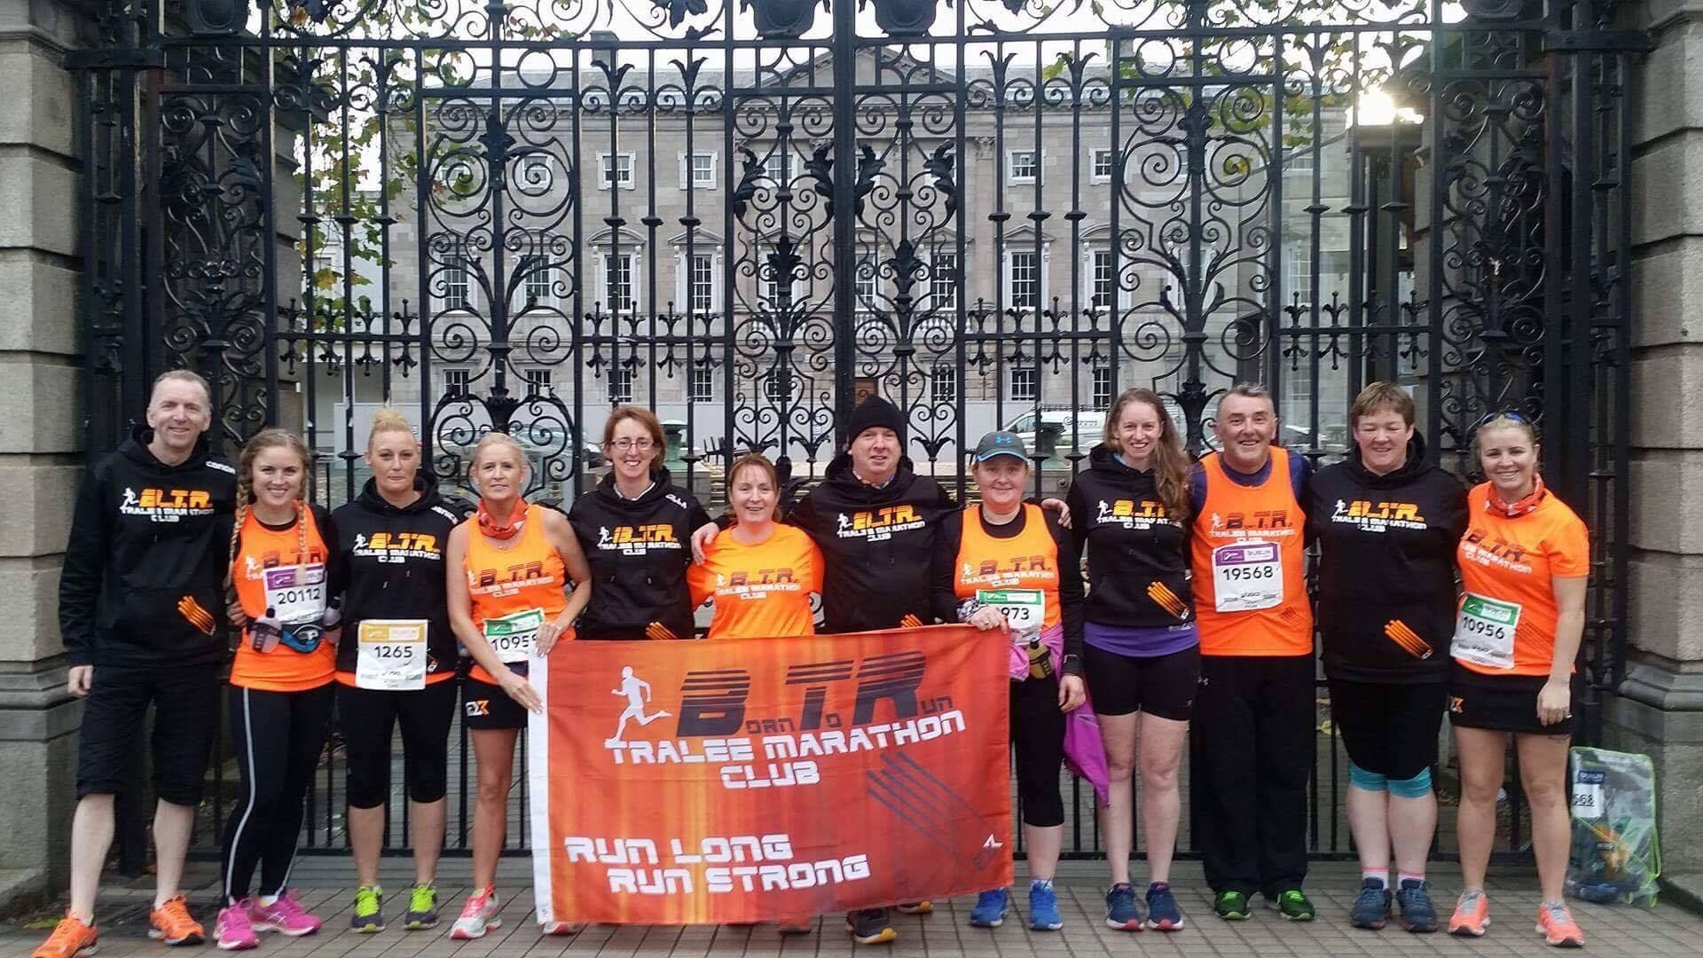

2017

Introduction
The year 2017 was always going to be a challenging one for the club. With the club founder Marcus Howlett leaving for pastures new a different approach was required and club members were needed to fill the void. To this end it was felt a meeting should be held to discuss the future of the club and the call out was made to all our members to attend the first Born to Run AGM at the Brogue Inn in October 2016.
On that night and at a subsequent EGM in March a Club Constitution was put in place and a committee elected to oversee the development and running of the club for the year. The committee elected by those present was as follows.
Chairperson: Brian O’ Shea Vice-Chairperson: Tom Foley Secretary: Liam Horan
Treasurer: Greta Quirke PRO: Colin Ahern/Maria Moynihan* Registrar: Kirstie McTrusty
Fundraising Officer: Marilyn O’Shea Social Officer: Ashley Kean O’Shea
Volunteer Coordinator: Danny O’Shea Minutes Secretary: Ann O’ Shea
Ordinary Members: Mary O’ Donnell, JJ O’ Connell, Sandra Byrne, David Hughes, Catherine Griffin, Marie O Shea, Niamh Abeyta.
*Maria was appointed by the committee after Colin stepped down.
The committee met approximately once a month and over the course of the year dealing with matters such as club social functions, club gear, the 40 mile ultra event, recruitment of new members, mentoring, fundraising, public relations and communication. I would like to thank the committee members for their work and commitment over the year and all our members for representing the club with pride and distinction the length and breadth of the country and indeed the world over.
What follows is a brief description of some of the clubs achievements and activities over the year and some hopes and aspirations for the year ahead.

Section 1
The Year in Review
Social Activities
The club’s main social event of the year has long been the annual Christmas party and this year was no exception. We would like to thank the Ashe Hotel for putting on an exceptional event once again and the organising committee for doing so much good work to make for an enjoyable night for all who attended. This year we are heading back to the Ash Hotel on December 1st and I’m assured an equally fun night is in store.
The Brogue also deserve a special mention as they once again put on a great show in March for the post Tralee Harriers International Marathon BTR party that’s always a crowd favourite. Fiona and her staff continue to be a great supporter of the club and it is they who host all our committee meetings throughout the year.
The club has also had great nights in Listowel, Dingle and Dublin following events and such social activity contributes in a significant way to reinforcing the spirit and bond of the club and its members.
Public Relations
Communicating our message to the wider public and spreading awareness of the club is vital to keeping the club vibrant and relevant. Colin and subsequently Maria have been working hard all year to this end and local papers and publications have been very supportive. The ‘Kerryman’ and ‘Kerry’s Eye’ as well as the ‘Tralee Advertiser and ‘Tralee Outlook’ have featured the club in good news stories and this helps to maintain the growth of the club. We continue to make use of ‘Facebook’ and social media and have now 2060 followers. We also have this year launched our website borntorun.ie. A new website will be launched in the coming year dedicated to the Born to Run 40 Mile Ultra and we hope this will continue to expand the profile of the club. A particularly popular feature throughout the year has been the mini profiles that Maria has been bringing our ‘Facebook’ followers and these help to give a real tangible humane touch.
This year also saw the launch of the official club email info@borntorun.ie giving communications a more professional feel.
The club also featured in this year’s St. Patrick’s Day Parade, for the first time representing the club itself rather than Tralee International Marathon.

Club Gear
This year also saw Born to Run – Tralee Marathon Club form a partnership with a new club gear provider ‘Flux Athletic’. We thank ‘Radar Sports’ for their service to the club over the past number of years but look forward to working with ‘Flux’ in the coming years to bring our members a range of quality club wear and products.
A motion was proposed and carried at last year’s AGM to change the club colours from navy and white to orange and black. It was argued that this would make our athletes more noticeable at events and I believe it certainly has had that effect. We now stand out clearly in any crowd in our new orange strip with black trim. Flux have also designed gender specific running tops for extra comfort and combined with the quality material make for an excellent feel when running.
Flux and Born to Run have also launched our new alternative black strip with orange trim and our hoddie in the same colours. With the cold winter months ahead the Born to Run buff may also be a welcome addition to your running wardrobe. All these products are now available from Flux Athletic.com.

BTR 40 Mile Ultra
Although this July saw the third running of the event, this was the first organised by the club itself. Indeed it was the first event of any kind organised by the club. This year also for the first time saw the introduction of a team relay event that proved hugely popular. This sell out event was an overwhelming success and the feedback from those that took part was without exception positive. Some examples of this were as follows.
‘It was my 175th marathon, so I've run every course around the country, and this race ranks as highly as any of them’.
‘There were stewards at every junction this year, and they were fantastic’,
Johnny Healy
‘Firstly huge congratulations on a brilliant, brilliant event, enjoyed it to bits as I am pretty sure everybody did. To all involved a huge thank you. Great touch with the Aqua Dome’
Liz Leonard

‘As it was my first ultra marathon I honestly didn't know what to expect but was extremely impressed with the set up from the word go .. course was well set out plenty of stewards who always had a kind word and smile every loop surface was excellent plenty of water and food along the way .. photographers on course .. and to me every person involved in the running of the event could not have done more for the runners .. I was very pleased with the event and everyone involved should be very proud of their efforts as it was a top class event and one I would highly recommend to anyone who will listen to me as it's one that I will never forget...’
Don Hannon
‘Well can I say ye all went above and beyond the call of duty with this event my 3rd year running it and yesterday was amazing Tanx u very much for everything’
Theresa Grimes
‘It was a fantastic event. A huge thanks you to everyone involved in the organisation. Well done for a great day’.
Lucy Fitzell
The above is just a taste of the feedback we received praising our event and members. A huge congratulations must go to everyone who helped make the event such a success. It could not have taken place without the support of so many club members who gave of their time so freely to make the event so special and paint our club in such a positive light.
More information on the clubs expenditure and income from the event is available in the treasure’s report.

Registration
The level of membership in the club is difficult to gauge as there has not been a tradition of official registration until more recent times. However with some careful research I did manage to identify 465 individuals who at one time or another identified themselves as Born to Run members. This was done mostly by reviewing online race results since 2012. In addition approximately 40 new members joined this year bringing the total to something in the region of 500 members, since the clubs humble beginnings as a society in IT Tralee. While it is impossible to say exactly how many of these still regard themselves as members, one indication of how healthy current membership is can be seen in the 100 plus responses to this year’s pole regarding the club name. It is my hope going forward to get a clearer indication of club strength by encouraging people to register with the club. This will also make communication within the club far more effective as there will be contact details available to the club secretary.
Mentoring
Attracting new members is vital to sustaining the club going forward and it would be impossible to do this without the selfless time dedicated by our club mentors. Each and every one of us started out in the BTR mentoring programme that has brought us from couch to 5k/10k/half marathon/marathon and beyond. These club members deserve special praise for helping to maintain the spirit of the club and show our new members just what can be achieved with commitment and determination. The novice group have now completed 5K 10K and 10 mile distances and will soon make their half marathon debut at Listowel later this month.
Competing Near and Far
Club discounts were again acquired for our members from the organisers of Dingle Half/Full Marathon and Listowel Half Marathon and 10k. Some 40 members competed in Dingle this year and we are expecting a similar number to travel to Listowel. This is a sign of the clubs continued strength and that the organisers of these events welcome our participation.
We also had large numbers compete as always at the Tralee Harriers International Marathon and Dublin again saw a club well represented. Club members took on the might of the Kerry Way Ultra and did themselves and their club proud. We provided pacers for events again this year an indication of the respect the club has within the running community.
Our members have again completed marathons and half marathons throughout the country and the USA, Britain and Continental Europe has seen the BTR flag fly.

Members of our club have for the first time represented us in the mountains of the MMRA championship and ‘The Loopers’ have become a well known fixture on the circuit.
Our often over looked ‘Speedies’ have been at it again also competing and wining 5k and 10k events throughout the county and the work they put in to remain competitive deserves recognition.
Club Insurance
The club committee have this year organised club insurance. This insurance indemnifies the club for public liability that may arise from the actions of club members during official training sessions. Unfortunately at this point in time it does not cover personal accident but this may be revisited in the future depending on cost and club finances.
Fundraising
The clubs main fundraising event was bag packing in Dunne’s Stores in the run up to Christmas. This raised €2473.65 for the club and it took a huge effort from club members to reach that healthy total. A big thank you to all who gave freely of their time during this busy time of year some members going above and beyond the call of duty with the time and effort they put in.
The BTR 40 Mile Ultra also returned some funds to the club and details are contained in the Treasurer’s Report.

Section 2
A Vision for 2018

Social Activities
While running is of course the main activity of the club and essentially the reason it exists, other activities organised by the club for its members play an important role in making the club a better and more enjoyable entity to be part of. The Christmas Party this year again returns to the Ashe Hotel on December 1st and we are hopeful for the usual healthy turn out.
The spring will see the return of Tralee Harriers International Marathon and so will signal time for our famous (or infamous depending who you ask) after-party.
The summer however has seen a gap in our social calendar and possibly an outdoor event of some description would be a good addition. What this may involve is unclear at the present time but membership input will be welcome.
Registration
As was noted earlier in the report there has not been a tradition of club registration in BTR. I would like to see this change into the future to provide us with a clearer picture of club membership numbers and to facilitate better communications in the club. It will not be obvious to the general membership but I did encounter much difficulty throughout the year organising things like group registration for Dingle, the pole on the Club name, the AGM, pick up of club gear amongst others. Membership of the club is guaranteed to be free by decree of the constitution and registration will not affect this
Furthermore while we have been lucky to date an incident involving a club member and a car this year has highlighted to us the lack of emergency contact details for our members, should the worst happen.

Public Relations
Born to Run has benefited from prominent coverage of our ‘Couch to 5k’ launch and of our ’‘40 Mile Ultramarathon’. We will endeavour to maintain good relations with local media in the coming year to grow the profile of the club and our events. This year has also seen an emphasis on promoting the personalities within the club and sharing their inspiring personal journeys through regular profiles on our Facebook page. It is envisaged that they will continue into the new year and that they will be archived on our website for future reference.
Our website is still new and hopefully it will continue to grow and improve in the year and develop into an invaluable resource for our members and the public. Our 40 Mile Ultra event will soon have its own dedicated website and this will launch early in 2018.
We will hopefully make increased used of local print media as we seek to have our club notes included regularly alongside other sports clubs.
Our Facebook page continues to grow in popularity and now has 2060 followers, there is no reason why this will not continue to grow and reach an ever increasing audience.
Growing the Club
In order for the club to remain in as good a shape as it currently is it must continue to grow. To this end Born to Run plans to launch another ‘couch to’ programme next year. Planning will begin soon in relation to what form this launch will take and when the programme will commence.
In order to run the programme however we need the continued support of or experienced club members to help guide new members by sharing their knowledge and experience. We would love to see more club members volunteer as mentors to this end.
As well as attracting new members another challenge is in retaining them once they start. A large fall off can be noted each year after mile stones are reached and a plan needs to be put in place to encourage those members who do not have a desire to progress to longer distances to still feel that they belong to the club and to continue to engage with us. Club members are invited to give their thoughts and suggestions towards this.
In addition to new members there are hundreds of people who at one time or another during the club’s seven year history felt part of the club, over 500 in fact that I have been able to identify although more no doubt exist. It would be wonderful for the club if we could attract just

a fraction of these back as active members. I envisage an event late spring or early summer designed to bring some old faces back to the club. The format that this will take is yet to be discussed and it is more a suggestion or feeler I’m putting out to club members to get feedback and ideas.
Fundraising
We will be returning to Dunne’s Stores again this year in the run up to Christmas as a repeat of last year’s bag packing and volunteers are urgently need to help make it a success once more. Plans are in their early stages also for the 40 Mile Ultra and we hope that this will again turn a small profit for the club. Other events or initiatives may be launched during the year by the fundraising sub-committee.
40 Mile Ultra
The BTR- Tralee Marathon Club 40 Mile Ultra will return next July and hopefully the event will be just as successful as 2017. The new web site will soon go live and dates and registration details will be announced.
A New BTR Race Event
Many of our members have expressed a desire to have the club host another event of shorter distance and I feel this is a great idea. Hopefully the incoming committee will agree with this also and put on another race during the year, that is more accessible to a greater number of runners.
Club Gear
I hope the year ahead will see us continue to develop a strong partnership with Flux Athletic. They are already producing a strong range of products that help promote the clubs identity and I envisage the range growing further in the coming year and I know Ger is open to suggestions to add to the range.
Overseas Race
While only a thought at present I believe it could be a great experience for the club to travel abroad as a group and take part in a race in another country. As a first attempt at something like this Britain may be the wisest choice and an event that has a marathon and half marathon on the same day would give the maximum appeal. Apart from that the idea as I say is at its infancy. Feedback and suggestions are as always welcome.

Club Sub-Committees
This year will hopefully see the introduction of club sub-committees. These will give invaluable assistance to the club officers in certain area and provide the opportunity for more club members to have an input. These will be the ‘Social and Cultural Committee’, the ‘Public Relations Committee’, the ‘Finance Committee’ and the ‘Race Committee’. All members are welcome to partake and should contact the relevant officer.
Mountain Running
From November 2017 BTR will introduce a new mountain running mentored programme. If interested see the ‘Facebook’ page for details and updated.

